a)Write a sed command that print lines numbersof lines beginning with “O”

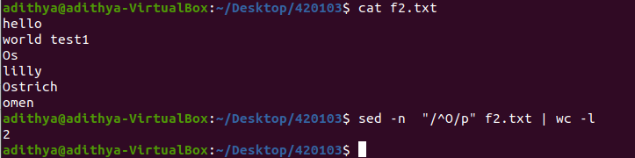

b)Write a sed command that delete digits in the given input file.

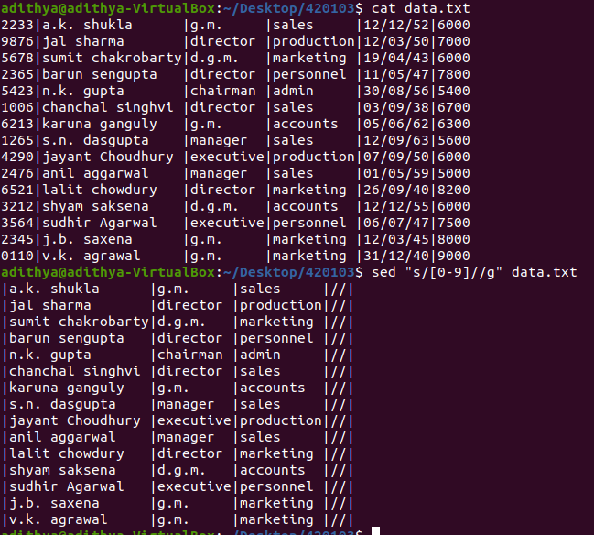

c)Write a sed command that delete lines that contain both BEGIN and END

d)Write a sed command that delete lines that contain BEGIN but not END

e)Write a sed command that deletes the first character in each line in a file

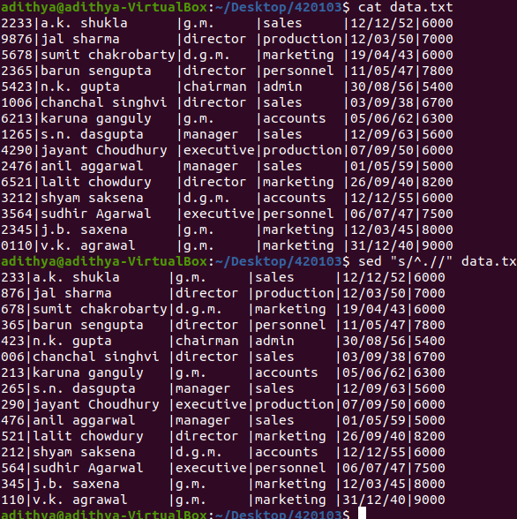

f)Write a sed command that deletes the last character in each line in a file

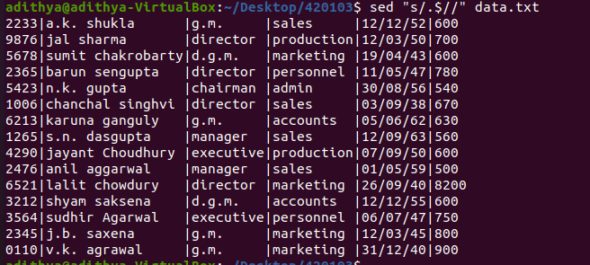

g)Write a sed command to delete character before last character in each line in a file

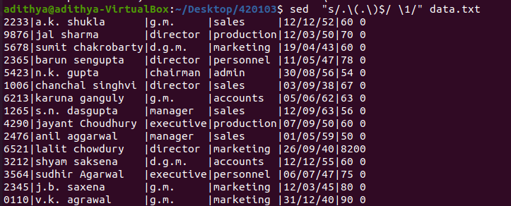

h)Write a sed command that swaps the first and second character in each line in the file

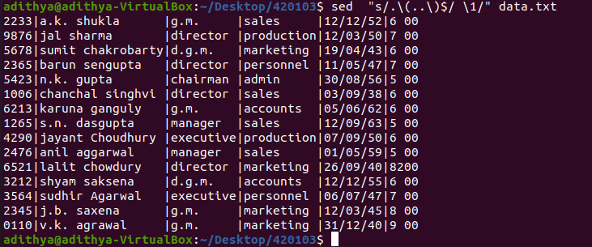

i)Write a sed command that swaps the first and second word in each line in the file

